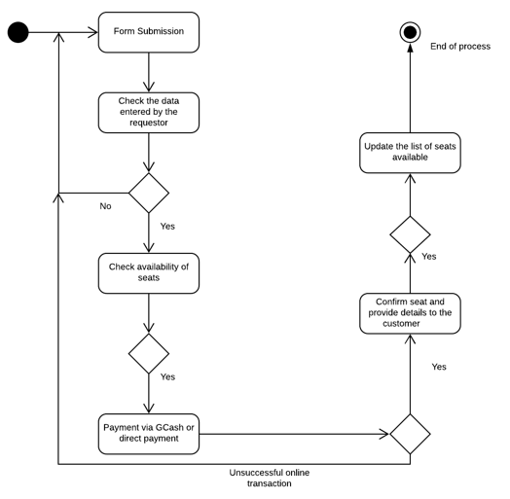**Activity Diagram**

Payment

Booking Clerk

Requestor